Ôn cuối kì các bước:

Trước tiên, bạn cần cài đặt Node.js nếu chưa có:  
**Tải xuống tại đây:** <https://nodejs.org/>  
**Kiểm tra cài đặt:**

node -v

npm -v

Bước 1: Tạo folder chứa dự án và chạy lệnh

npm create vite@latest 21123741-tranVanLuc-ck --template react

Di chuyển vào thư mục dự án:

cd 21123741-tranVanLuc-ck

npm install

Bước 2: Cấu trúc thư mục ,dự án sử dụng **React Router** để điều hướng giữa các trang. Chạy lệnh sau:

npm install react-router-dom

copy data ảnh được cho vào assets

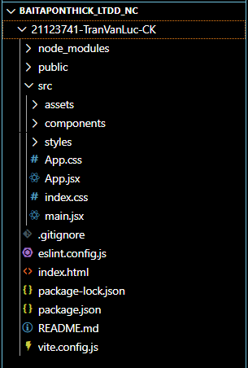

Bước 3: main.jsx

import React from 'react';

import ReactDOM from 'react-dom/client';

import { BrowserRouter } from 'react-router-dom';

import App from './App';

import './index.css';

ReactDOM.createRoot(document.getElementById('root')).render(

  <BrowserRouter>

    <App />

  </BrowserRouter>

);

Bước 4: App,jsx

import React from "react";

import { Routes, Route } from "react-router-dom";

import StartScreen from "./components/StartScreen";

import DetailScreen from "./components/DetailScreen";

function App() {

  return (

    <Routes>

      <Route path="/" element={<StartScreen />} />

      <Route path="/detail" element={<DetailScreen />} />

    </Routes>

  );

}

export default App;

Bước 5: components/StartScreen.jsx

import React from "react";

import { useNavigate } from "react-router-dom";

import "../styles/StartScreen.css";

const StartScreen = () => {

  const navigate = useNavigate();

  const handleStart = () => {

    navigate("/detail");

  };

  return (

    <div className="start-container">

      <img src="/src/assets/voice.jpg" alt="App Logo" className="logo-animation"/>

      <h1 className="fade-text">Welcome to Premium!</h1>

      <div className="dots-animation">...</div>

      <button className="start-btn" onClick={handleStart}>

        Start listening

      </button>

    </div>

  );

};

export default StartScreen;

styles/StartScreen.css

.start-container {

    background-image: url('/src/assets/Image 301.jpg');

    background-size: cover;

    background-position: center;

    height: 100vh;

    display: flex;

    flex-direction: column;

    justify-content: center;

    align-items: center;

    color: white;

  }

  .fade-text {

    font-size: 2rem;

    animation: fadeIn 2s ease-in-out;

  }

  .dots-animation {

    font-size: 2rem;

    animation: bounce 1s infinite;

  }

  .logo-animation {

    width: 80px;

    height: 80px;

    font-size: 3rem;

    animation: pulse 2s infinite;

    margin-bottom: 20px;

  }

  .start-btn {

    background-color: black;

    color: white;

    border: none;

    padding: 15px 25px;

    font-size: 1rem;

    margin-top: 20px;

    border-radius: 10px;

    cursor: pointer;

  }

  /* Animations */

  @keyframes fadeIn {

    0% { opacity: 0; transform: translateY(20px); }

    100% { opacity: 1; transform: translateY(0); }

  }

  @keyframes bounce {

    0%, 100% { transform: translateY(0); }

    50% { transform: translateY(-5px); }

  }

  @keyframes pulse {

    0%, 100% { transform: scale(1); }

    50% { transform: scale(1.1); }

  }

Bước 6: Tạo database để lưu

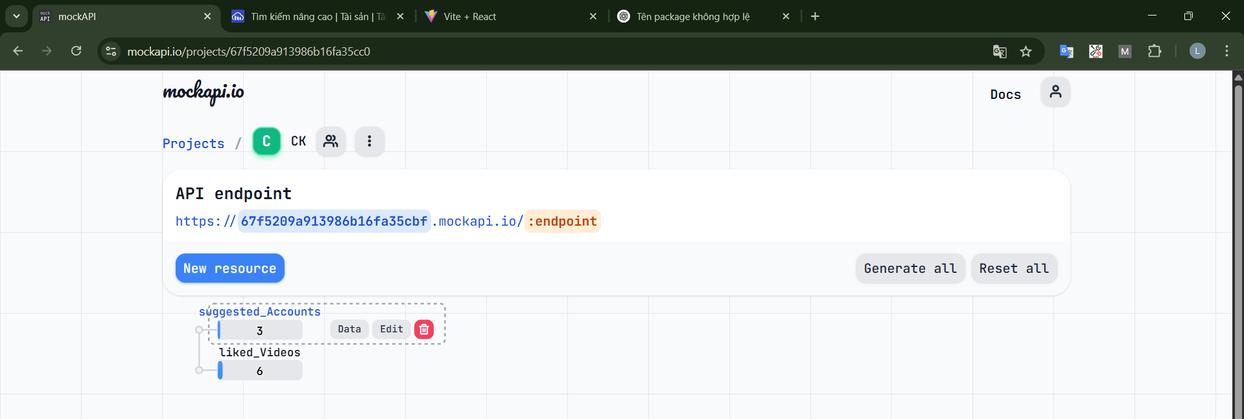

Tạo link ảnh.

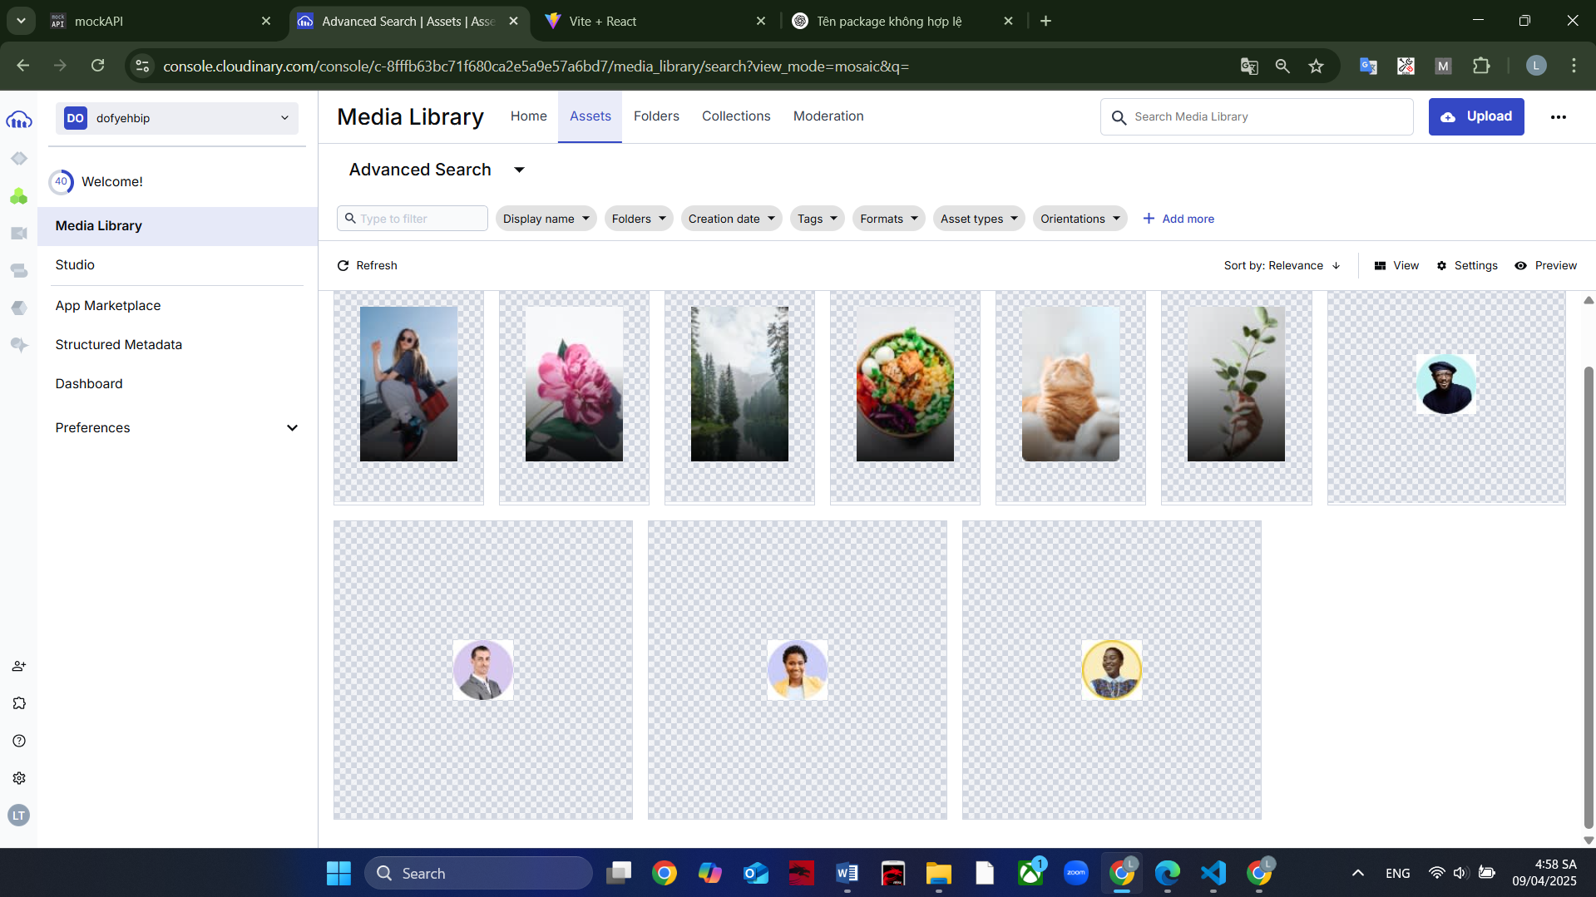

Cấu trúc data mẫu

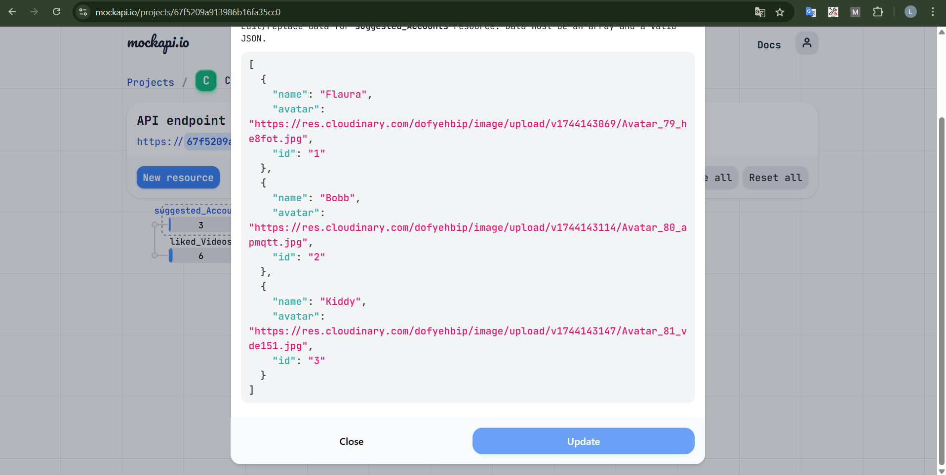

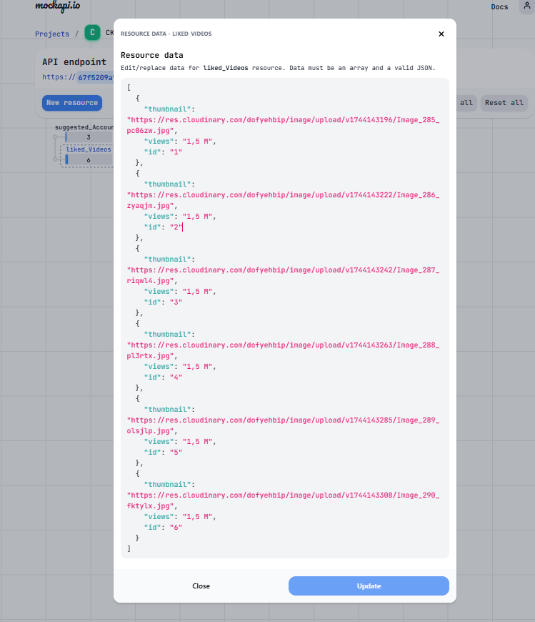

Bước 7: components/DetailScreen.jsx

import React, { useEffect, useState } from 'react';

import '../styles/DetailScreen.css';

function DetailScreen() {

  const [suggestedAccounts, setSuggestedAccounts] = useState([]);

  const [likedVideos, setLikedVideos] = useState([]);

  useEffect(() => {

    fetch('https://67f5209a913986b16fa35cbf.mockapi.io/suggested_Accounts')

      .then(res => res.json())

      .then(data => setSuggestedAccounts(data));

    fetch('https://67f5209a913986b16fa35cbf.mockapi.io/liked_Videos')

      .then(res => res.json())

      .then(data => setLikedVideos(data));

  }, []);

  return (

    <div className="detail-screen">

      <div className="profile-section">

        <img src="/src/assets/Avatar 78.jpg" alt="avatar" className="avatar"/>

        <h2>Kiran Glaucus</h2>

        <p>I love a colorful life ❤️❤️❤️</p>

        <div className="stats">

          <span>203<br />Following</span>

          <span>628<br />Followers</span>

          <span>2634<br />Likes</span>

        </div>

        <div className="btn-group">

          <button className="follow-btn">Follow</button>

          <button className="message-btn">Message</button>

        </div>

      </div>

      <div className="suggested-section">

        <h3>Suggested accounts <a href="#">View more</a></h3>

        <div className="suggested-list">

          {suggestedAccounts.map((acc) => (

            <div key={acc.id} className="account-card">

              <img src={acc.avatar} alt={acc.name} />

              <p>{acc.name}</p>

              <button>Follow</button>

            </div>

          ))}

        </div>

      </div>

      <div className="video-section">

        <div className="tab">

          <span className="tab-label">🎥 Videos</span>

          <span className="tab-label active">❤️ Liked</span>

        </div>

        <div className="video-list">

          {likedVideos.map(video => (

            <div key={video.id} className="video-card">

              <img src={video.thumbnail} alt="video" />

              <div className="video-info">

                <span className="icon">▶</span>

                <span className="views">{video.views} views</span>

                <span className="heart">♡</span>

              </div>

            </div>

          ))}

        </div>

      </div>

    </div>

  );

}

export default DetailScreen;

styles/DetailScreen.css

.detail-screen {

  background-color: #fff;

  color: #000;

  padding: 20px;

  font-family: 'Segoe UI', Tahoma, Geneva, Verdana, sans-serif;

}

.profile-section {

  text-align: center;

}

.avatar {

  width: 80px;

  height: 80px;

  border-radius: 50%;

  object-fit: cover;

  border: 3px solid #ffd700;

  margin-bottom: 10px;

}

.stats {

  display: flex;

  justify-content: center;

  gap: 30px;

  margin: 10px 0;

  font-weight: bold;

}

.btn-group {

  display: flex;

  justify-content: center;

  gap: 10px;

  margin-top: 10px;

}

.follow-btn, .message-btn {

  padding: 8px 16px;

  border: none;

  border-radius: 20px;

  font-weight: bold;

  cursor: pointer;

}

.follow-btn {

  background-color: #5865f2;

  color: #fff;

}

.message-btn {

  background-color: #f0f0f0;

  color: #333;

}

.suggested-section {

  margin-top: 30px;

}

.suggested-section h3 {

  display: flex;

  justify-content: space-between;

  align-items: center;

}

.suggested-list {

  display: flex;

  justify-content: space-between; /* căn đều khoảng cách */

  flex-wrap: wrap;

  gap: 16px;

  margin-top: 12px;

}

.account-card {

  width: calc(33.333% - 10.66px); /* chia đều 3 cột trừ khoảng cách */

  display: flex;

  flex-direction: column;

  align-items: center;

}

.account-card img {

  width: 64px;

  height: 64px;

  border-radius: 50%;

  object-fit: cover;

  margin-bottom: 8px;

}

.account-card p {

  margin: 4px 0;

  font-weight: 500;

}

.account-card button {

  background-color: #5b5ff0;

  color: white;

  border: none;

  padding: 6px 12px;

  border-radius: 20px;

  cursor: pointer;

  font-size: 14px;

}

.video-section {

  margin-top: 30px;

}

.tab {

  display: flex;

  justify-content: center;

  gap: 20px;

  margin-bottom: 15px;

}

.tab-label {

  font-weight: bold;

  color: gray;

  position: relative;

  cursor: pointer;

}

.tab-label.active {

  color: #5865f2;

}

.tab-label.active::after {

  content: '';

  display: block;

  width: 100%;

  height: 2px;

  background-color: #5865f2;

  position: absolute;

  bottom: -5px;

  left: 0;

}

.video-section {

  margin-top: 32px;

}

.video-list {

  display: grid;

  grid-template-columns: repeat(3, 1fr);

  gap: 16px;

}

.video-card {

  position: relative;

  overflow: hidden;

  border-radius: 12px;

}

.video-card img {

  width: 100%;

  height: 200px;

  object-fit: cover;

  border-radius: 12px;

}

/* overlay ở dưới ảnh */

.video-info {

  position: absolute;

  bottom: 0;

  left: 0;

  padding: 6px 10px;

  width: 90%;

  display: flex;

  justify-content: space-between;

  align-items: center;

  color: #fff;

  font-size: 14px;

}

.icon {

  margin-right: 5px;

}

.heart {

  font-size: 16px;

}

Bước 8: chạy run npm dev để chạy ứng dụng